Return Path
Electrical return path is the path taken by electric current to flow back to its source after completing a circuit.
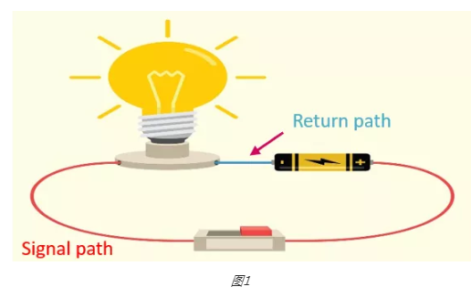
Low-Frequency Return Path (DC / Low-Speed Signals)
How current returns
- Current follows the path of least resistance
- Return current spreads out in all available ground copper
- Exact physical path is not critical
Typical frequency range
- DC to a few kHz (sometimes up to tens of kHz)
PCB behaviour
- Ground plane acts like a big copper sheet
- Return current distributes widely
- Small gaps or slots in GND usually do not matter much
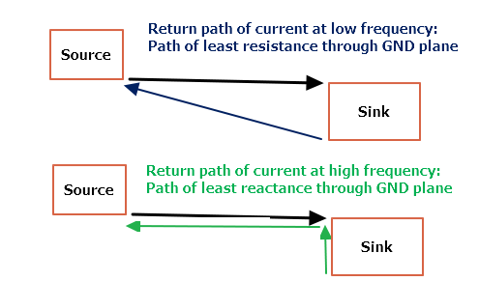
High-Frequency Return Path (High-Speed / Fast Edge Signals)
How current returns
- Current follows the path of least impedance
- Return current flows directly under the signal trace
- It forms a tight loop with the forward signal
Typical frequency range
- > 1 MHz
- OR signals with fast rise/fall time (even if clock is low)
PCB behaviour
- Return path is controlled by capacitance & inductance
- Ground plane under the trace is mandatory
- Any break in return path causes:
  - EMI
  - Reflections
  - Crosstalk

Checklist for maintaining good return path
Before Routing
- ☐ Solid, continuous GND plane defined
- ☐ Signal layers adjacent to GND layer
- ☐ No GND splits under high-speed nets
During Routing
- ☐ High-speed signals routed over GND plane
- ☐ No routing across plane gaps / voids
- ☐ Signal and return path kept close
- ☐ Short, straight routes (minimum detours)
- ☐ Same reference plane maintained
- ☐ No stubs or dangling branches
- ☐ 45° bends / arcs used (no 90° corners)
- ☐ Differential pairs routed together & symmetric
Layer Changes
- ☐ Minimized via count
- ☐ GND stitching via placed near every signal via
- ☐ Return path continuity verified after layer change
Power & Decoupling
- ☐ Decoupling caps placed very close to IC pins
- ☐ Short, wide connection to GND plane
- ☐ PWR used as return path only if well-decoupled
Final Review
- ☐ Loop area minimized
- ☐ Fast signals kept away from board edges
- ☐ No high-speed signal over split power plane

High-speed design is not about “drawing a trace” — it’s about controlling where the return current flows.

